Community and stakeholder engagement:
Resource and design tools

February 2020

Department of Water and Environmental Regulation
8 Davidson Terrace
Joondalup Western Australia 6027
Telephone +61 8 6364 7000
Facsimile +61 8 6364 7001
National Relay Service 13 36 77
www.dwer.wa.gov.au
© Government of Western Australia
February 2020
This work is copyright. You may download, display, print and reproduce this material in unaltered form only (retaining this notice) for your personal, non-commercial use or use within your organisation. Apart from any use as permitted under the Copyright Act 1968, all other rights are reserved. Requests and inquiries concerning reproduction and rights should be addressed to the Department of Water and Environmental Regulation.

Disclaimer
This document has been published by the Department of Water and Environmental Regulation. Any representation, statement, opinion or advice expressed or implied in this publication is made in good faith and on the basis that the Department of Water and Environmental Regulation and its employees are not liable for any damage or loss whatsoever which may occur as a result of action taken or not taken, as the case may be in respect of any representation, statement, opinion or advice referred to herein. Professional advice should be obtained before applying the information contained in this document to particular circumstances.

This publication is available at www.dwer.wa.gov.au or for those with special needs it can be made available in alternative formats such as audio, large print, or Braille.

Contents
Setting the consultation parameters 5
Consultation parameters explainer 7
Stakeholder identification 9
Stakeholder mapping template 10
Participation and consultation methods matrix 11
Consultation plan template 12

Resource and design tools
The Department of Water and Environmental Regulation has established guidelines for stakeholder consultation.
Please use the following tools to build the information required for the consultation plan you are working on.

Setting consultation parameters
Complete the following template and answer the following questions to ensure the parameters of the consultation are clearly defined. This allows for transparent consultation and minimises any potential for misunderstanding

Overview of negotiables and non-negotiables
As identified in Step 1 – Assessment in the Overview.

Negotiables | Non-negotiables

What are the timeframes of the project?
Is there a compulsory start or finish date? Does it impact other projects? Are there political/government considerations (ie. elections) that need to be taken into account?

Milestone | Date
Pre-project
Start
Milestone 1
Milestone 2
Milestone 3
Feedback
Completion and review

Are there any statutory/legislative requirements that need to be taken into account?

What specialist knowledge or technical expertise is required?

What reporting is required?
Do any external bodies require a specific type of report or support information (ie. Ministerial briefing)?

Report type | Audience | Timeframe

Are there any known constraints on resources? If so, how will this impact the process?

Consultation parameters explainer
The following is an example of how the parameters of a consultation would be outlined to stakeholders during the call for participation / input:

The consultation process will assist the department in determining the following factors:
- {insert negotiables here}
- {insert negotiables here}
- {insert negotiables here}
- {insert negotiables here}.

However, the following factors are outside of the scope of this consultation because of the reasons outlined:

Factor | Reason for exclusion

As such, any submissions or feedback pertaining to the above factors will be excluded from the consultation evaluation.
Excluded submissions, and their reason for exclusion, will be made available at the conclusion of the submission period.

Stakeholder identification
The following stakeholder identification tool is helpful in brainstorming potential stakeholder groups. Include all groups of people who could or will be impacted by the project and use this as the basis to build the full stakeholder list.
Political interest
Other
Project name
Social interest
Environmental
interest
Economic
interest

Stakeholder mapping template
After identifying stakeholder groups, use Post-It notes to add stakeholders/ stakeholder groups to the below matrix – this allows you to easily move them to different sectors if necessary, throughout the life of the project.

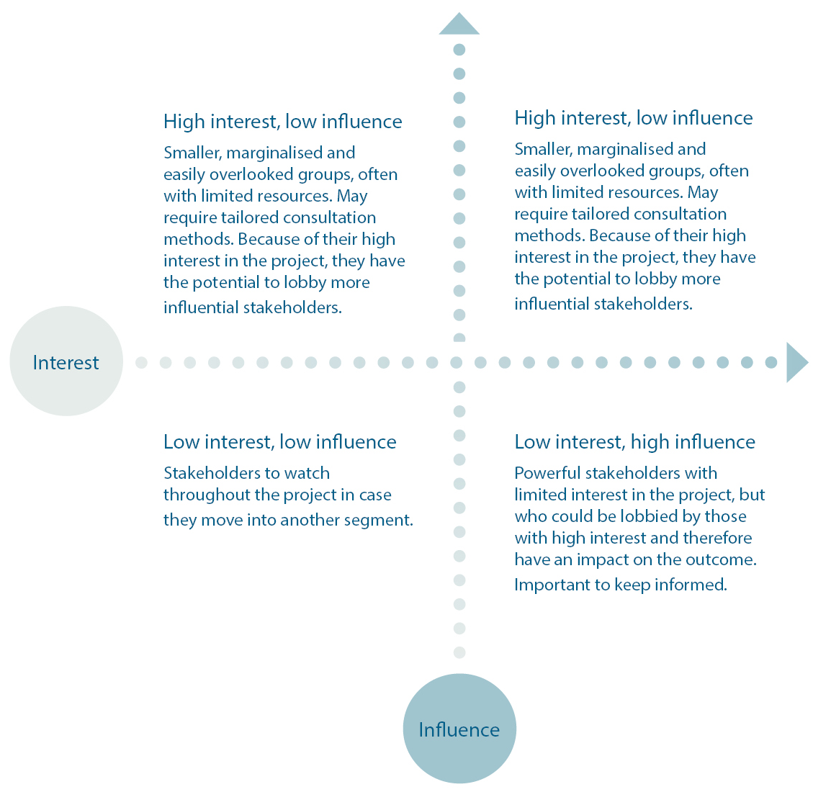

Participation and consultation methods matrix
Different stakeholders require different levels of participation, depending on their influence and interest in the project. Given the diverse nature of the department’s role in the community, it is likely consultation will occur across multiple.

 | Inform | Consult | Involve | Collaborate | Empower
Goal | To provide the public with balanced and objective information to assist them in understanding the problem, alternatives, opportunities and/or solutions. | To obtain public feedback on analysis, alternatives and/or decisions. | To work directly with the public throughout the process to ensure that public concerns and aspirations are consistently understood and considered. | To partner with the public in each aspect of the decision, including the development of alternatives and the identification of the preferred solution. | To place the final decision-making in the hands of the public.
Promise | We will keep you informed. | We will keep you informed, listen to and acknowledge concerns and aspirations, and provide feedback on how public input influenced the decision. | We will work with you to ensure your concerns and aspirations are reflected in the alternatives developed and provide feedback on how public input influenced the decision. | We will look to you for advice and innovation in formulating solutions and incorporate your advice and recommendations into the decisions to the maximum extent possible. | We will implement what you decide.
Consultation methods | - Newsletters  - Direct mail  - Social media posts  - Website banners  - Website copy  - Brochures/flyers  - Posters  - Signage  - Advertising  - Community noticeboards  - Open house  - Media coverage/media release | - Focus groups  - Surveys – online and hard copy  - Discussion papers  - Community meetings  - DWER-organised meeting/forum  - Meetings with advisory groups/ associations  - Door knocking | - Summits and workshops  - Development of a new committee or group  - Polling and surveys (including via social media)  - Face-to-face meetings | - Steering committees  - Advisory groups  - Working groups | - Voting/ballots  - Task force  - Self-managed committee or group

