Community and stakeholder engagement overview

February 2020

Department of Water and Environmental Regulation
8 Davidson Terrace
Joondalup Western Australia 6027
Telephone +61 8 6364 7000
Facsimile +61 8 6364 7001
National Relay Service 13 36 77
www.dwer.wa.gov.au
© Government of Western Australia
February 2020
This work is copyright. You may download, display, print and reproduce this material in unaltered form only (retaining this notice) for your personal, non-commercial use or use within your organisation. Apart from any use as permitted under the Copyright Act 1968, all other rights are reserved. Requests and inquiries concerning reproduction and rights should be addressed to the Department of Water and Environmental Regulation.

Disclaimer
This document has been published by the Department of Water and Environmental Regulation. Any representation, statement, opinion or advice expressed or implied in this publication is made in good faith and on the basis that the Department of Water and Environmental Regulation and its employees are not liable for any damage or loss whatsoever which may occur as a result of action taken or not taken, as the case may be in respect of any representation, statement, opinion or advice referred to herein. Professional advice should be obtained before applying the information contained in this document to particular circumstances.

This publication is available at www.dwer.wa.gov.au or for those with special needs it can be made available in alternative formats such as audio, large print, or Braille.

Contents
1. Consultation guidelines and process 6
1.1 Purpose of our guidelines 6
1.2 Principles of consultation 6
1.3 Consultation statement 8
1.4 The consultation process 8
2. Consultation tools and templates 18

Introduction
These guidelines outline the philosophy and principles of the Department of Water and Environmental Regulation (the department) on stakeholder consultation.
The principles provide clarity and direction around why the department consults with stakeholders, and the expectation on staff to plan for and undertake consultation in certain ways.
A version of these principles should be included within all consultation documentation (both internal and external).
If you wish to suggest changes to the content or templates, or have any other questions, please contact the Community and Public Relations Manager in Strategy and Engagement.

Consultation guidelines and process

Purpose of our guidelines
Our guidelines outline the department’s consultation process, ensuring consistent good practice.
These guidelines offer a strategic approach to consultation and include the department’s principles of consultation, levels of participation, an overview of consultation methods and advice on stakeholder analysis and mapping.

Principles of consultation
The department has established five principles for stakeholder consultation.
These principles have been developed following a 2019 review of the department’s consultation methods and taking into account feedback from both department staff and external stakeholders.
Each of these principles align with current consultation and engagement best practice.
Integrity
We incorporate suitable consultation strategies at the project planning stage, and clearly understand the intended purpose of the engagement.
- We know why we need to consult, and plan for this early in each and every project.
- We involve stakeholders from the start and make it clear when and how we will consult, what the purpose of the consultation is and what can and can’t be influenced in this process.
- We respond to stakeholders in a timely, respectful manner and appreciate differing viewpoints and beliefs.
- We respect our stakeholders’ expertise and enter into consultation with an open mind.
Accessibility
We ensure our stakeholders have access to consultation opportunities and strive to reduce barriers to participation.
- We strive to include stakeholders in consultation opportunities, no matter how remote their location or limited by their availability.
- We communicate in a way that can be understood and appreciated by all stakeholders.
- We strive to ensure all relevant stakeholders are made aware of consultation opportunities in a timely manner and have ample opportunity to respond.
- We will provide stakeholders with the information they need to participate in a meaningful way.
- We will endeavour to provide a range of consultation and feedback options to meet different stakeholder needs.
Transparency
We are open and honest about our engagement.
- We will share the purpose of the consultation with stakeholders.
- We will make it clear how the stakeholder feedback and information will be used, where it may be published and how feedback will be communicated.
- We will disclose any information that may impact the outcomes of the consultation, including where existing decisions have been made.
- We request and expect stakeholders will also disclose any information that could impact the process (for example, where there are significant minority views within representative associations that differ from the association’s own view).
Feedback
We will close the loop, analysing feedback objectively and providing stakeholders with updates on consultation outcomes in a timely manner.
- We recognise and respect the time and effort stakeholders make in providing information and feedback.
- We will strive for objective and fair analysis of all feedback and information gathered during the engagement process.
- We will respond to stakeholder feedback as soon as practical and in clear, accessible language.
Consistency
We do what we say we are going to do and work together as a team to undertake effective and consistent consultation.
- We understand the importance of working closely with stakeholders, regardless of their views, in a way that is consistent across the department.
- We recognise our colleagues’ unique strengths, expertise and experience and help one another to undertake effective engagement.
- We recognise that different projects will require different consultation and communication methods but that the fundamental principles of consultation do not change.

Consultation statement
Based on the principles the following consultation statement has been created in order to briefly explain the department’s philosophy on consultation:
We actively seek to consult with stakeholders, consider differing views and explain our findings in a consistent and transparent manner in order to sustainably manage and protect Western Australia’s water and environment.

The consultation process
The department’s four-step model has been adapted from the quality-assurance standard of the International Association for Public Participation (IAP2).
This model incorporates consultation in the earliest phases of project analysis and planning, ensuring stakeholders are engaged early and often.
This process may be repeated several times throughout a project’s life cycle with the feedback and review phase leading into a new period of assessment and consultation as the project evolves.
Four steps of consultation:
- Step 1: Assessment
- Step 2: Resource and design
- Step 3: Execution
- Step 4: Feedback and review

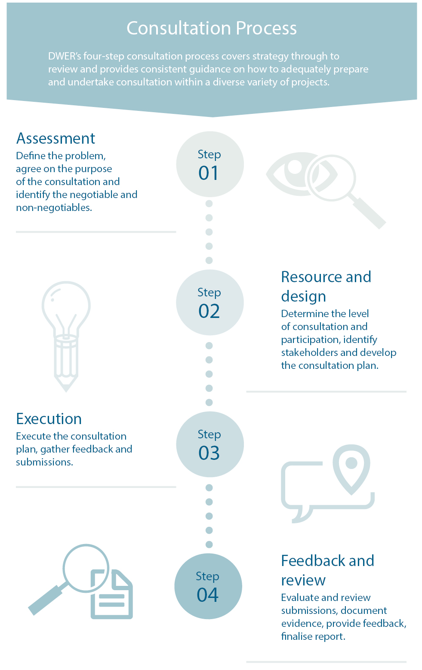

Step 1: Assessment
Clearly assessing and defining the problem is a key component to planning and delivering effective consultation. This will make it easier to select effective methods of consultation and understand what a successful outcome looks like. It will also create clarity for stakeholders from the outset on which aspects they can influence, and which are non-negotiable.
This stage has four components:
- Define the problem
What is the issue that needs to be addressed, answered or resolved?
- Agree on the purpose
What are the objectives of the project and of the consultation? At this stage it is also pertinent to set key performance indicators/measurements for the project.
- Identify the negotiables and non-negotiables
This allows the project owner to clearly identify the parameters of the consultation and make this clear to stakeholders from the very beginning. To identify the negotiables and non-negotiables, ask yourself the following questions:
- What cannot be influenced by stakeholders? (i.e. because of budget, government’s stated policy, legislation, safety)
- What aspects of the project can be influenced by stakeholders?
- Define the level of impact
The impact of the project on the community will define the methods, style and length of consultation. The level of impact will also provide guidance on which stakeholder groups will be directly and indirectly affected.
The following quadrant can be used to define the level of impact:

 |  | Number of people affected
 |  | Statewide | Local
Impact | High | Level 1  High impact on a mass scale | Level 2  High impact on a select scale
 | Low | Level 2  Low impact on a mass scale | Level 3  Low impact on a select scale

It is important to note the level of impact may change throughout a project, which may also necessitate a change in consultation methods used. The project team should revisit the level of impact throughout the project life cycle to ensure it remains relevant.

Step 2: Resource and design
The assessment phase provides the project team with the foundation to design the consultation program and ensure it has the resourcing and support it needs to undertake the necessary level of community engagement.
The components of this stage are:
- Outline the parameters of the consultation
It is recommended that a statement of feedback should be developed that outlines to all stakeholders how the information they provide will be used in the decision- making.
Using the information gained in Step 1.3 (identify the negotiables and non-negotiables), clearly outline the parameters of the consultation and ensure these are clearly available and accessible in communications to stakeholders.
These parameters will become particularly important during the feedback and review stage, as they will determine which submissions and feedback received during consultation will be excluded and which will be incorporated into the project development.
The following questions about the project should be addressed at this time:
- What are the timeframes of the project?
- Are there any statutory requirements?
- What specialist knowledge or technical expertise is required?
- What reporting is required, and when?
- What constraints do we have on resources and how will this impact the process?
- Identify and map stakeholders
Start by creating a list of stakeholders who will or may be impacted by the project. In order to identify these stakeholders, ask yourself the following questions:
- Who has an environmental interest in the project?
- Who has an economic interest in the project?
- Who has a political interest in the project?
- Who has a social interest in the project?

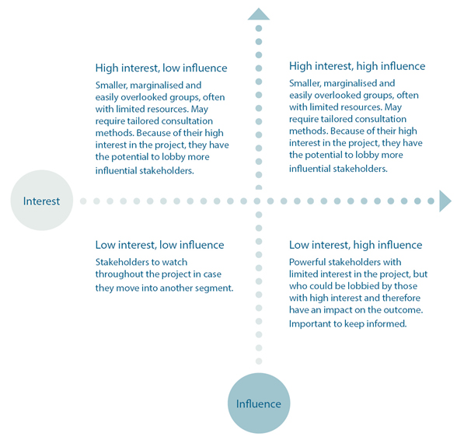
It is also useful to map stakeholders depending on their interest in the final outcome, and their power and potential to influence or impact the outcome as per the following map:
- Determine the level of participation
Defining the level of participation early helps both stakeholders and the project team to understand what can be expected of the consultation process. The levels of participation will be influenced by the parameters of the consultation (Step 2.1). They are also likely to differ between stakeholder groups depending on the mapping undertaken in the Step 2.2.
Use the following IAP2 spectrum to determine the level of participation. Be aware different stakeholder groups may require differing levels.

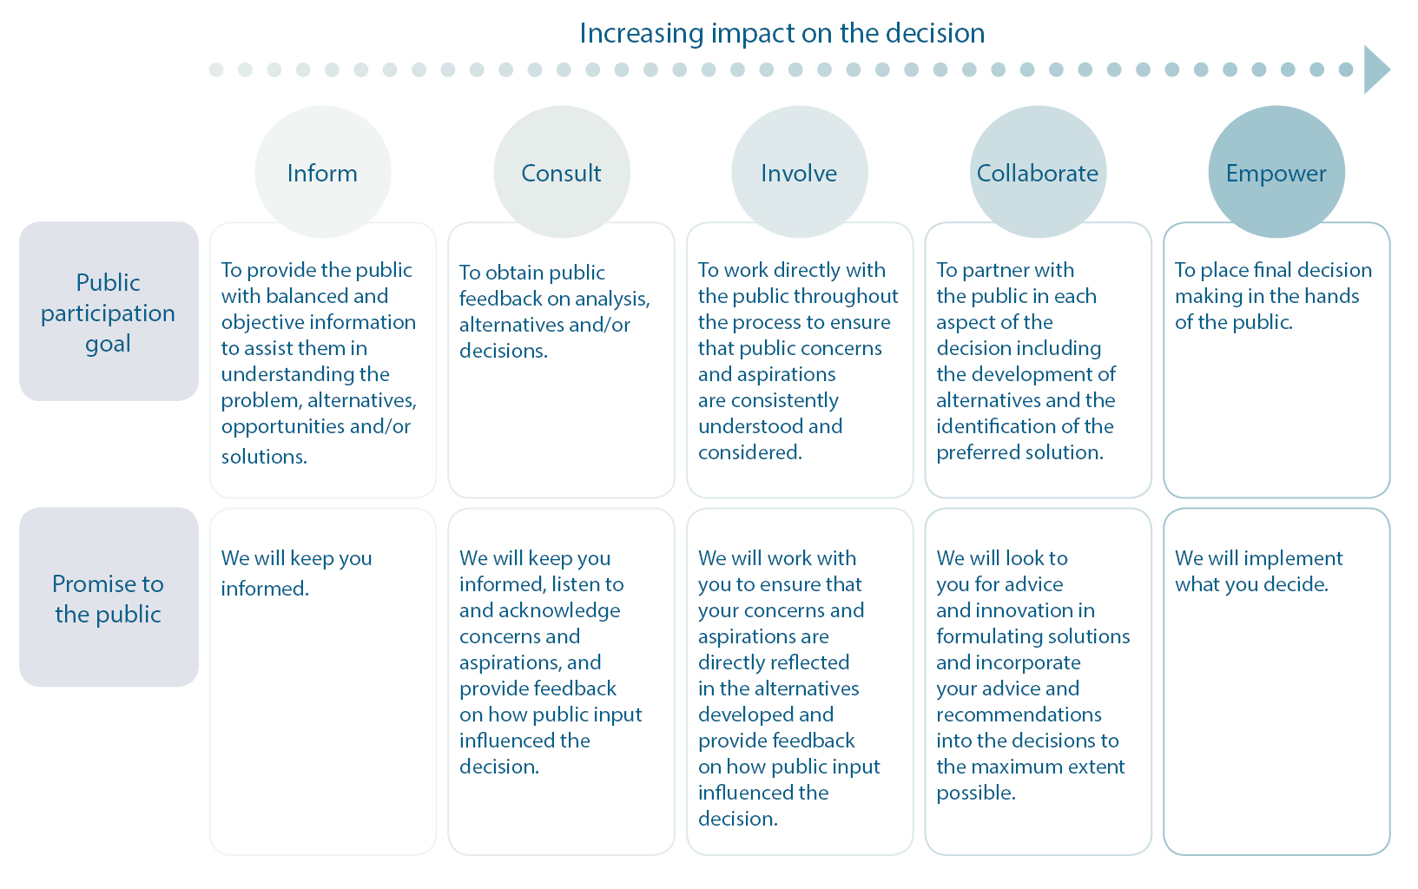

- Determine the methods of consultation and develop the consultation plan
The final component of the planning stage is to use the information gathered to determine the best methods for consultation for each stakeholder group.
Suitable methods for each level of participation are outlined below:
Level of participation | Consultation method
Inform | E-newsletters
 | Social media posts
 | Website banners
 | Website copy
 | Direct mail
 | Newsletters
 | Brochures
 | Flyers
 | Posters
 | Signage
 | Advertising
 | Community noticeboards
 | Open house
 | Media coverage
Consult | Focus groups
 | Surveys – online and hard copy
 | Discussion papers
 | Community meetings
 | DWER organised meeting/forum
 | Meetings with advisory groups/associations
 | Door knocking
Involve | Summits and workshops
 | Development of a new committee/group
 | Polling and surveys (including via social media)
 | Face-to-face meetings
Collaborate | Steering committees
 | Advisory groups
 | Working groups
Empower | Voting/ballots
 | Task force
 | Self-managed committee or group

A full list of methods, including information on which method/s align with the different levels of impact and different stakeholder groups, is also available.
When determining the methods of consultation, it is also important to take into account the following potential barriers to participation:
  - Geography – How do we engage stakeholders in remote locations and what resources are required to do this?
  - Technology – If we employ online methods of consultation, will this restrict stakeholders’ ability to take part?
  - Language – Does the information need to be translated?
  - Culture – Are there cultural sensitivities we need to accommodate (i.e. religious holidays, availability of women for private discussions, Native Title considerations)?
  - Education – Does the information need to be simplified?
  - Priorities – Do people have competing priorities that will impact their ability to participate (i.e. school pick-up, shift work, childcare)?
  - Perceived relevance – Do people understand this project will have an impact on them?
By answering these questions consultation methods can be further tailored to ensure accessibility and maximise participation, as well as to adequately plan resources or alert where resource shortfalls may be likely.
The final component of this step is to use all the information gathered to develop the Consultation Plan. A template for the Consultation Plan is also available.
Please ensure all Consultation Plans are noted by the relevant Ministerial office prior to executing it. Please note, if you propose establishing an online survey on the department’s website, all proposed questions need to be noted by the Ministerial office before requesting Corporate Communications makes such a survey ‘live’ on the website. For more information on this process, contact Corporate Communications

Step 3: Execution
The execution of the consultation plan includes:
- organising resources and developing information
- providing information to stakeholders
- inviting stakeholders to participate
- undertaking consultation activities
- rolling reviews of participation.
During the execution of the consultation plan it is also important to undertake the following reviews to ensure the plan is effective and relevant:
- Monitoring of stakeholder groups and sentiment
Throughout the project lifespan review the stakeholder groups identified in Step 2.2 to gauge their interest/influence changes. New stakeholders may also emerge during the execution of the consultation plan and they should be mapped and added to the consultation plan.
- Adjustment to consultation methods as required
If new stakeholders emerge or existing stakeholders’ shift in interest/influence, then the methods of consultation may also need to be adjusted. Refer to Steps 2.3 and 2.4 to determine if new methods need to be introduced.
- Monitoring of consultation methods to ensure they are reaching stakeholders
It is important to ensure stakeholders are aware they can participate in the consultation.
During execution of the consultation plan, monitor use of consultation methods to ensure they are being used and feedback/information is being received. If participation is lower than expected ask the following questions:
- Is the stakeholder list accurate? Have we missed anyone?
- Have we mapped the stakeholders correctly?
- What are the barriers to stakeholders taking part? Review the potential barriers identified in Step 2.
If any barriers are discovered, it is recommended the project team address these directly with a representative from the stakeholder group to find a solution that will enable them to participate.

Step 4: Feedback and review
This is the final step in the consultation process and includes the provision of feedback to stakeholders, the evaluation of information and finalisation of the policy, regulation or report.
- Evaluation and documentation of feedback
Once the consultation period has finished the information provided by stakeholders will be reviewed and, firstly, compared with the parameters developed in Step 2.1.
If some submissions need to be excluded from the process because they do not fit the parameters, then this should be recorded on the Excluded Submissions template.
Collate the included submissions and feedback from stakeholders and input this into the Response to Submissions report template.
Once all submissions have been reviewed and decisions made update the Response to Submissions with any relevant answers, information and feedback.
Send/make available the Response to Submissions and Excluded Submissions to all stakeholders who contributed, ensuring any private information is removed.
- Finalisation of policy, regulation or report
Include in the final policy, regulation or report a summary of any adjustments made to the project because of information and advice received during public consultation.
In order to close the loop, alert stakeholders where the final policy, regulation or report has been developed and where it can be accessed (if possible).
Also alert stakeholders if there is a significant delay or change to the parameters of the project after consultation has occurred.
- Review
An internal review of the consultation is the final step in this process and allows the department to learn from the things that went well and those that could have been improved.

Consultation tools and templates
Included on the intranet, along with this overview, are various tools and templates to help your consultation process:
- Assessment template
- Resource and design tools
- Consultation plan template
- Consultation case study template
- Mid-project consultation review template
- Consultation review template
- Feedback template
- Consultation case study template

